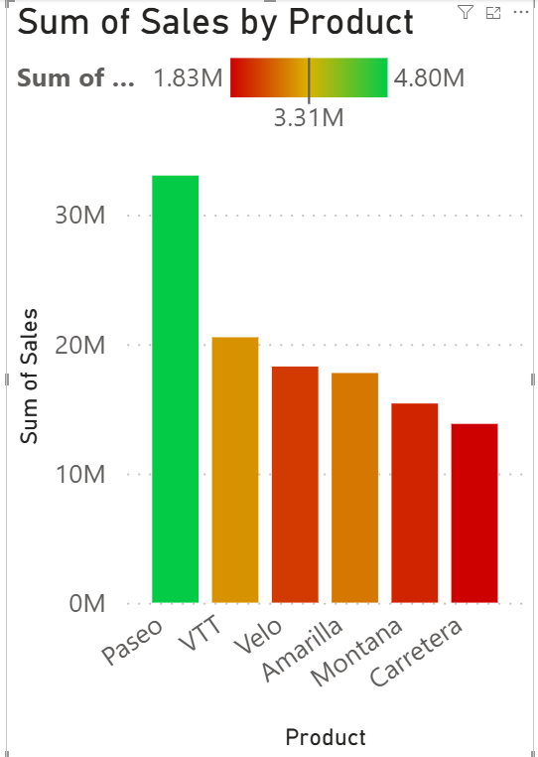

***CONDITIONAL FORMATTING***

***Steps:***

* ***In Report View Tab***

1. Visualizations tab ->Build Visual
2. Click on ***Stacked Column Chart***

* ***Data Tab***

1. ***Financials*** -> Select Column name according to the given question

* ***Build Visual***

1. X-axis -> product
2. Y-axis -> sum of sales

* ***Format Visual***

1. Format Visual -> visual

* ***Columns:***

Color-> conditional formatting

* ***Color-categories:***
* ***Format Style***->Gradient
* What field should we base this no? -> sum of profit
* Summarization->Sum
* How should we format empty values?->Don’t Format
* Minimum->Lowest Value(red)
* Center -> Middle value (Yellow)
* Maximum->Highest Value(green)
* Click on: Add middle ,color

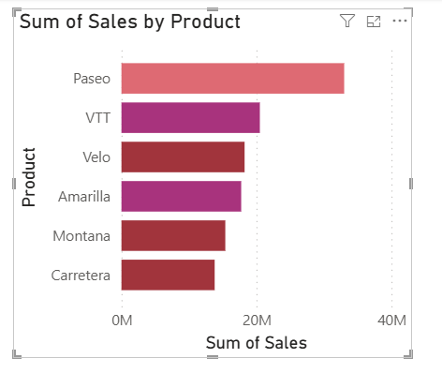

**CONDITIONAL FORMATTING WITH RULES**

**SETPS:**

* **In Report View Tab**

1. Visualizations tab ->Build Visual
2. Click on **Stacked Column Chart**

* **Data Tab**

1. **Financials** -> Select Column name according to the given question

* **Build Visual**

1. X-axis -> Product
2. Y-axis -> Sum of Sales

* **Format Visual**

1. Format Visual ->Visual

* **Columns:**

Color -> Conditional Formatting

* **Color – Categories:**
* Format Style -> **Rules**
* What field should we base this on? -> **Sum of Profit**
* Summarization -> **Sum**
* If Value >= **35000,** Number and <= **5000000** Number then color: **Violet**
* If Value >= **25000**, Number and <= **3500000** Number then color: **Orange**
* If Value >= **15000**, Number and <= **2500000** Number then color: **Pink**
* then press OK button.